

Details Create Quality

GENUO CNC PRESS BRAKE
WC67K-125T/3200
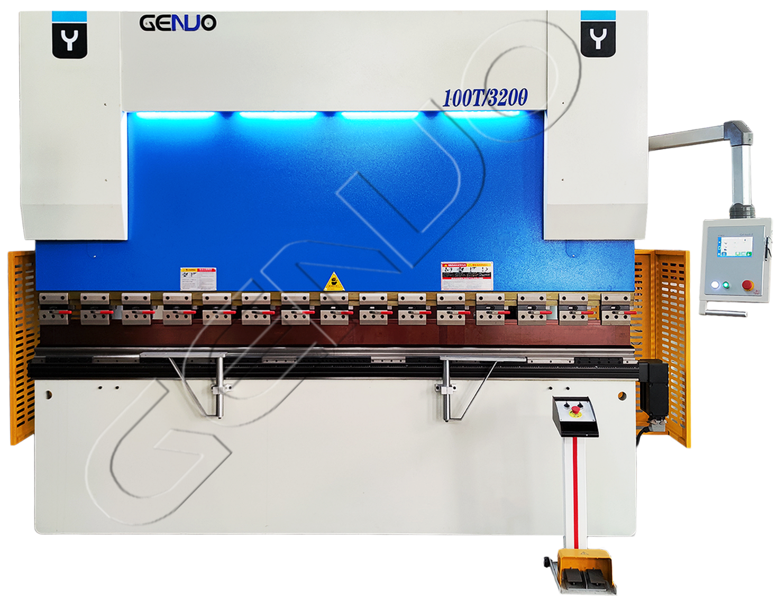

This document is for illustration only.Genuo reserves the right to modify any specification.
www.genuogroup.com
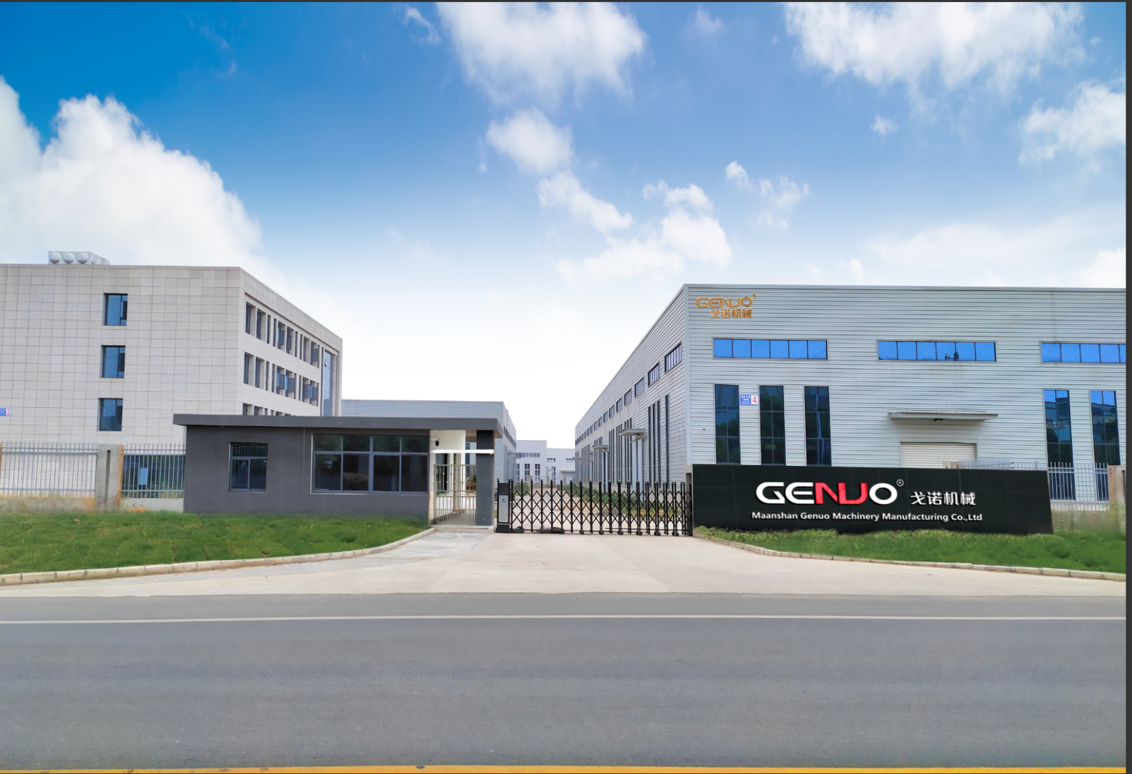
INTRODUCTION
GENUO is a company specializing in the design, manufacture and sales of sheet metal processing equipment, such as CNC Press Brake, hydraulic shearing machine, laser cutting machine, etc. with more than 20 years of experience, the company has more than 100 employees, more than 10 engineering and technical personnel, strong technical force, advanced processing equipment, scientific quality management, strong development ability Strength for the company's sustainable development has laid a good foundation.
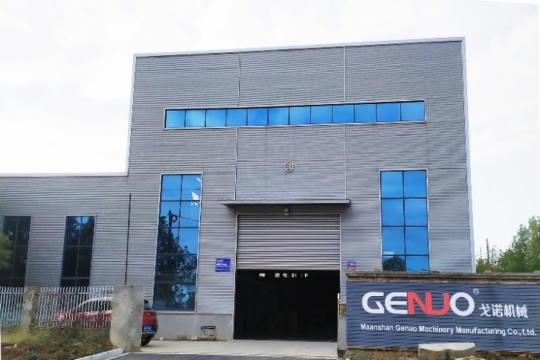
We are not only an ordinary manufacturer, our machines maximize the realization of independent R & D and production of machines and related accessories. With super high production and manufacturing standards.
Our products are all over the world, and are exported to Europe, America, Southeast Asia, Middle East and other regions. As our customers' trusted friends, pursuing perfection and perseverance is our customers' eternal goal. Continuous development and progress is our eternal pursuit. We are willing to work with you hand in hand, common development.

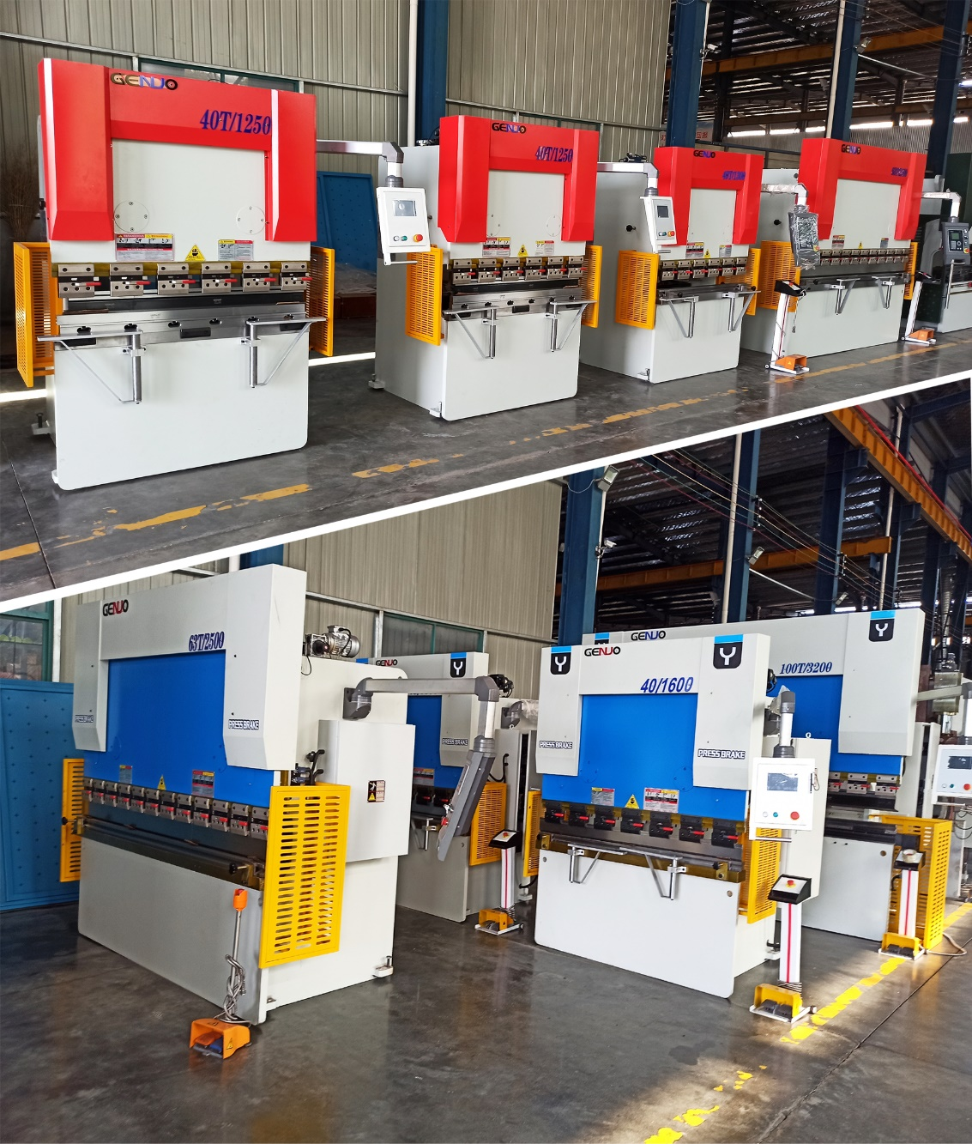
Features

Adhering to advanced design concept, simple appearance, comfortable operation human-machine experience
Special NC or CNC bending control system is fitted with mainframe of the bending machine.
Multi-work-step programming function is able to achieve an automatic operation and contnuous positioning of multi-step procedures,as well as an automatic precision adjustment for positions of back gauge stopper.
The machine is provided with bend counting function, for display of processing quantity and power-failure memory of positions of stopper and gliding block, as well as procedures and parameters.
IMported ball bearing lead screw and linear guide rail are used for rear stopper, to ensure the positioning precision of rear Stopper, for processing precision of machine to be higher.
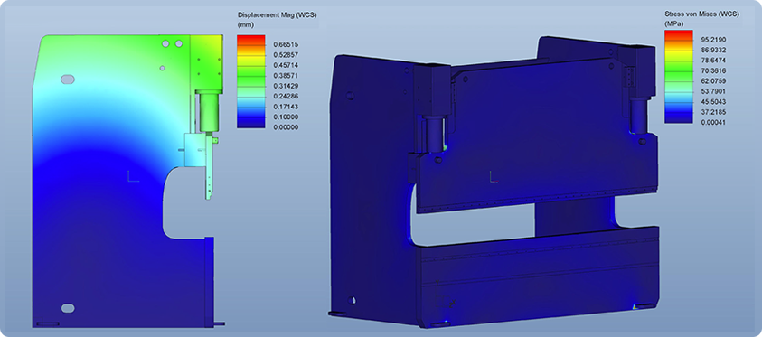
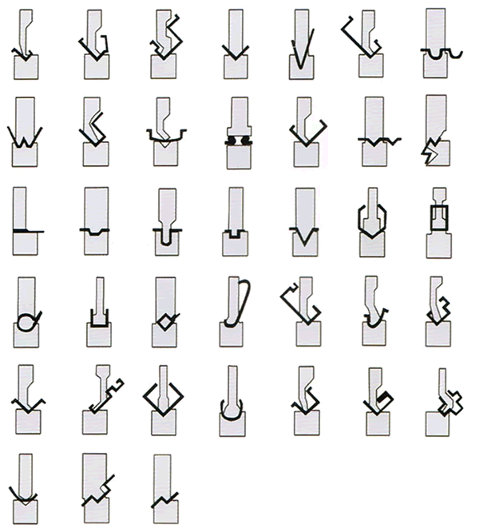
GENUO have vast experience with R&D and designing components to very tight tolerances with SOLIDWORKS 3D CAD modelling techniques,and that CAE software SOLIDWORKS used as the method to analyze the linear static construction, stress and deformation for machine frames. So for complicated structures, highly complex loading’s and transient modelling.
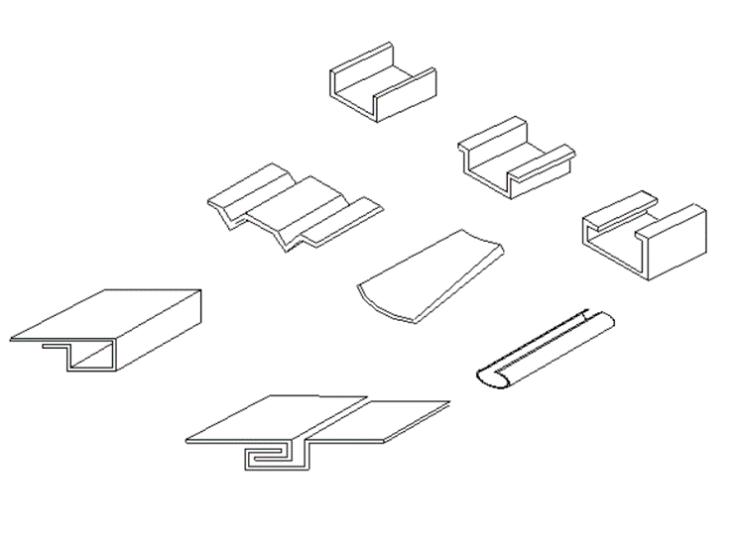
Parameter

Number | Project |  | Parameter | Unit | Remark
1 | Nominal pressure |  | 1250 | KN
2 | Working table length |  | 3200 | mm
3 | Column spacing |  | 2510 | mm
4 | Throat depth |  | 320 | mm
5 | Ram stroke |  | 120 | mm
6 | Max open height |  | 380 | mm
7 | Main motor power |  | 7.5 | kw
8 | Approaching speed |  | 150~180 | mm/s
9 | Working speed |  | 1~20 | mm/s
10 | Return speed |  | 100~150 | mm/s
11 | Machine accuracy | Slider repeatability | ±0.1 | mm
11 | Machine accuracy | Slider positioning accuracy | ±0.1 | mm
11 | Machine accuracy | Backgauge repeat positioning accuracy | ±0.10 | mm
11 | Machine accuracy | Straightness of workpiece | ＜±0.6 | mm/m
11 | Machine accuracy | Bending angle error | ＜±0.6 | °
11 | Machine accuracy | Scale resolution | 0.05 | mm
12 | Machine size | Length | 4000 | mm
12 | Machine size | Width | 1950 | mm
12 | Machine size | Height | 2450 | mm
13 | Machine weight |  | 6800 | kg

DETAILS IMAGE

1.Control System
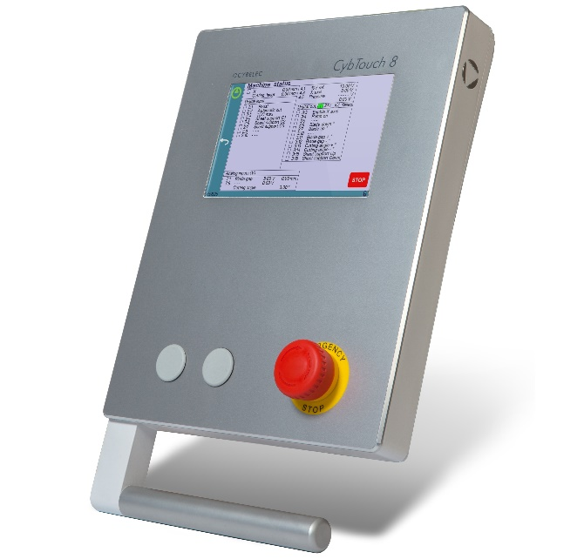
Cybelec CybTouch8, Switzerland

CybTouch 8P is specifically designed for conventional (with torsion bar) 2-axes or 3-axes press brakes. It has an intuitive and vivid color full touch screen and a high integration of functions. Its robust design is available in panel or housing version.Thanks to its large keys, online help, simplified software and many other automatic functions that constantly guide the operator, CybTouch is as simple as a positioner control.

2.Electrical Part

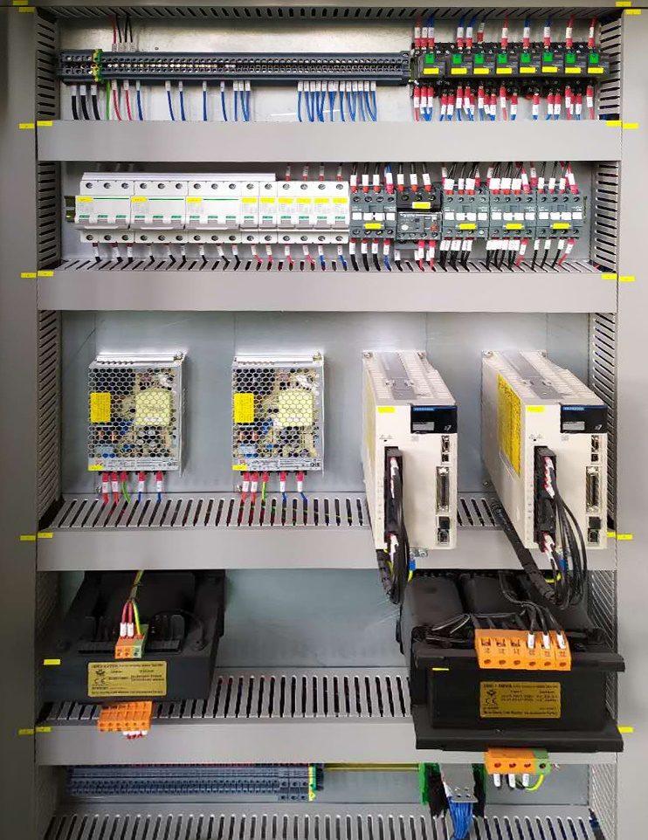

Stable Electrical Cabinet

Durable France Schneider electrics ensure the stableoperation of the machine.Reasonable line connection and arrangement greatly reduces the failure rate. The integrated control module of hydraulic valve group makes the sliding block move smoothly and accurately. And the operator and all parts of the machine played a good protection.

3.Hydraulic System

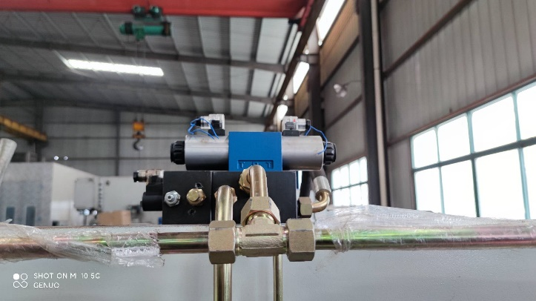

Superior Hydraulic System

Integrated Rexroth hydraulic system, quick response. The low failure rate makes the machine run safely, efficiently and stably.The whole series of standard is equipped with galvanized cold drawn pipe and German EMB ferrule type pipe joint. Reduce the risk of oil leakage by 50% compared with rubber and welded seamless tubing. And in can be longer service life.

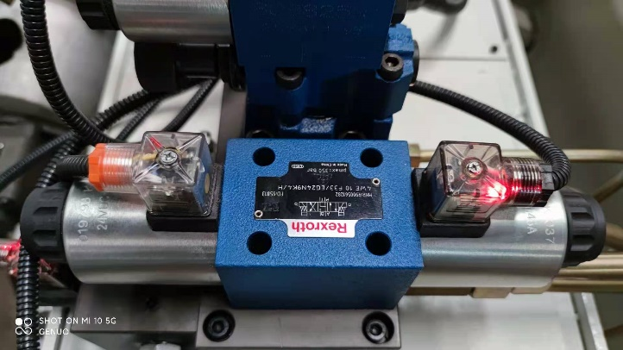

4.Stopping Device

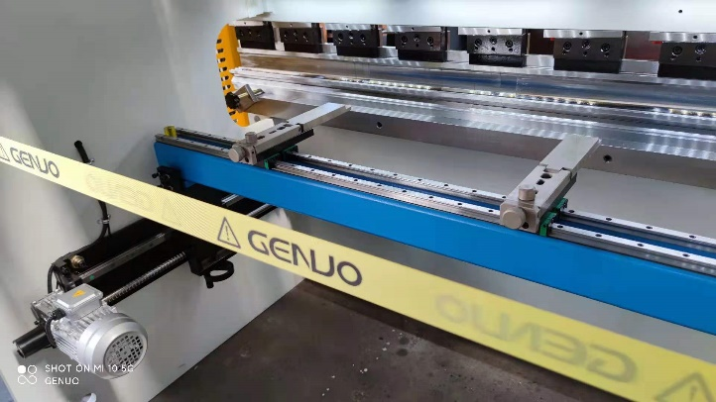

Convenient Back-Gauge(2 Axis)

The unique and novel ball screw linear guide structure back-gauge ensures high positioning accuracy.The straight double guide rail beam system is adopted. Multi-level with movable, adjustable stop fingers. Increased positioning range makes bending more efficient and accurate .
Optional function more Complete multiple Axes.

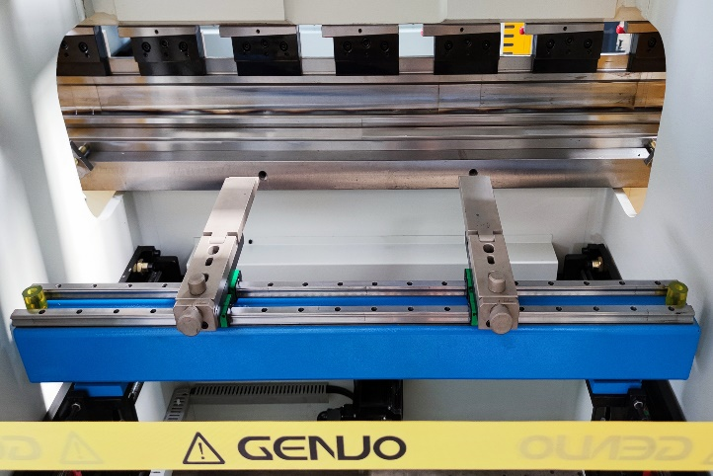

5.Power System

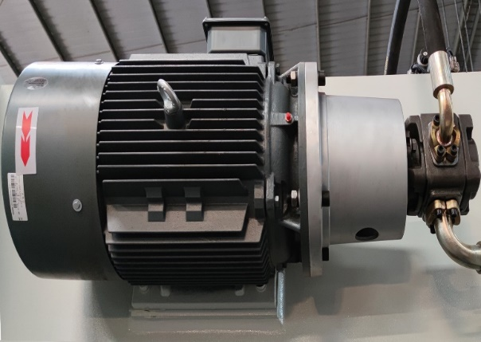

Low Noise and Powerful Force

Using Germany Siemens main motor and USA SUNNY or FIRST gear oil pump guarantee the machine service life and improve the machine working stability. Reasonable matching makes the machine burst out strong and lasting pressure.At the same time, the special coupling device also greatly reduces the noise of the machine in the process of running.

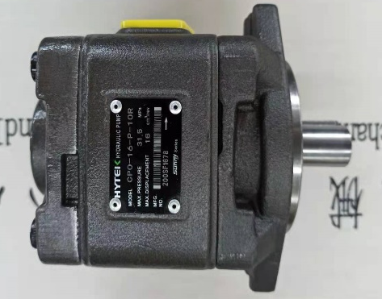
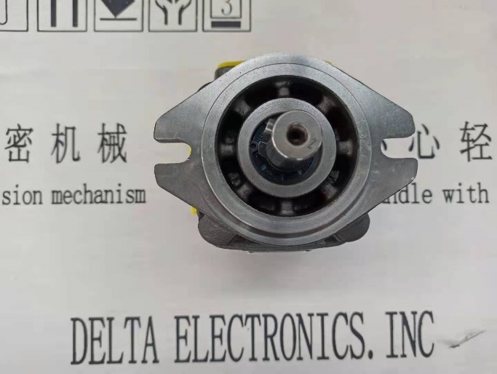

6.Configuration of Ergonomics

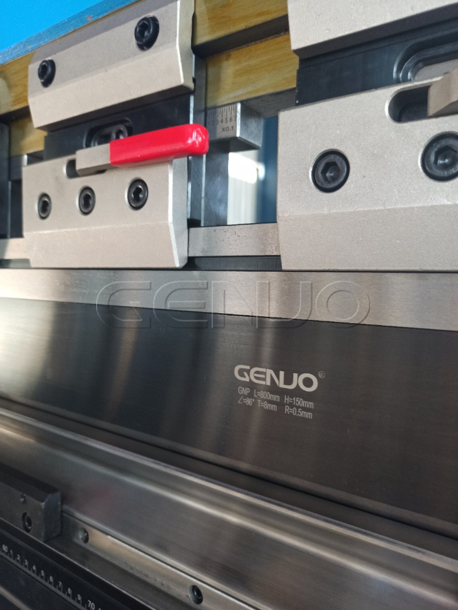

Patent Fast Clamp

The whole series adopts GENUO GNSP standard fast holders. Patented rear butterfly hold down device, which can adapt to different types of European-standard, Amada type punches. Compared with the traditional tool holder, it can save more time and improve production efficiency.Safety, anti falling.There are also one button release upgrade style. Automatic hydraulic and pneumatic clamping are optional.
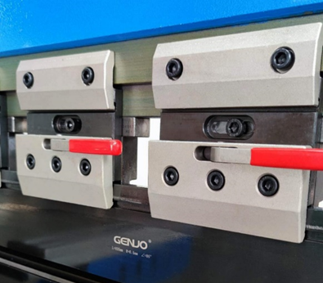

7.Press Brake Tools

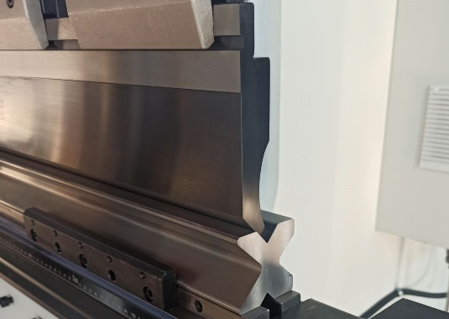

Diverse Press Brake Tools

Optimized design can make bending more simple and efficient. 42CrMo or C45 high frequency quenching process press brake tools, it is durable. Special surface nitriding treatment can be selected to prevent rust and beautiful appearance. Special punch and vdies can be customized according to the workpiece and GENUO provide a complete set of solutions.

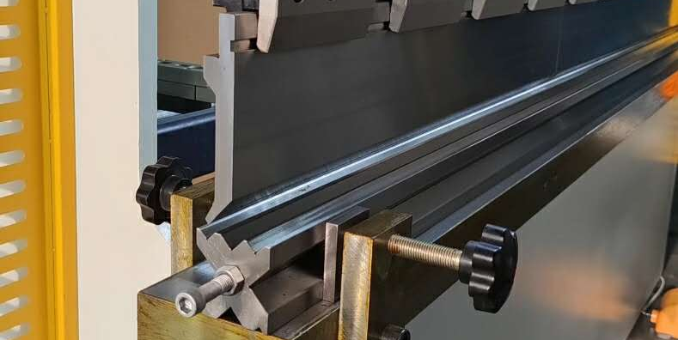

8.Optional Installation

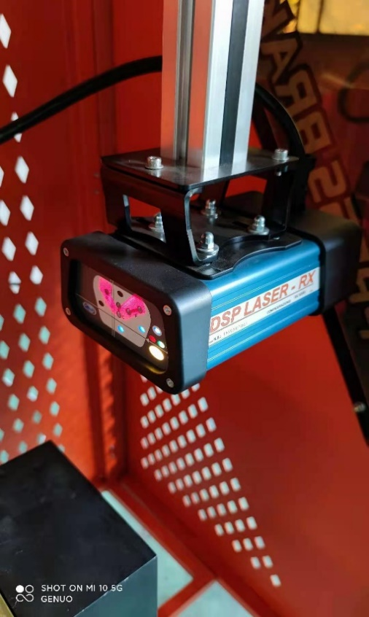

Patent Fast Clamp

* Motor Crowning

* Oil Cooling Unit

* Light Curtain

* Laser Protection

* Front Auto Follow support

* Bending Robots

List of Main Components

Number | Name | Configuration
1 | Control System | CybTouch 8, Switzerland
2 | Main Motor | South /Siemens,German
3 | Hydraulic system | Rexroth/Yonmin, German
4 | High pressure gear pump | FIRST/SUNNY, USA
5 | Pipe Connector | EMB, German
6 | Linear Guides | HIWIN,Taiwan
6 | Ball screw | HIWIN,Taiwan
7 | Cylinder sealing element | NOK, Japan
8 | Single/double pole air switch | Siemens/Schneider
9 | AC contactor | Siemens/Schneider
10 | Button | Siemens/Schneider
11 | Tools and Clamps | GENUO,China
List of accessories

1 | Toolbox | 1 box | /
2 | Grease gun | 1 pieces | /
3 | Anchor bolt | 4 pieces | /
4 | Adjusting bolt | 4 pieces | /
5 | Movable foot switch | 1 pieces | /
Number | Name |  | Quantity
1 | Machine User Manual |  | 1
2 | Controller Operation Manual |  | 1
3 | Electrical schematic diagram of machine tool |  | 1
4 | Hydraulic schematic diagram of machine tool |  | 1
5 | Machine tool installation and transportation hoisting diagram |  | 1
6 | Press brake tools drawing |  | 1
7 | Machine test report and certificate |  | 1
8 | Packing List |  | 1
Note: some of the above documents are bound in the same book


马鞍山戈诺机械制造有限公司 Https//:www.genuogroup.com
Maanshan Genuo Machinery Manufacturing Co., Ltd. MOB:0086 18355518185
Email:info@genuogroup.com FAX:0086 555 7168599 TEL:0086 555 7168598
ADD : East Industry Park, Bowang Town, Bowang District, Maanshan, Anhui, China

